Udf code :

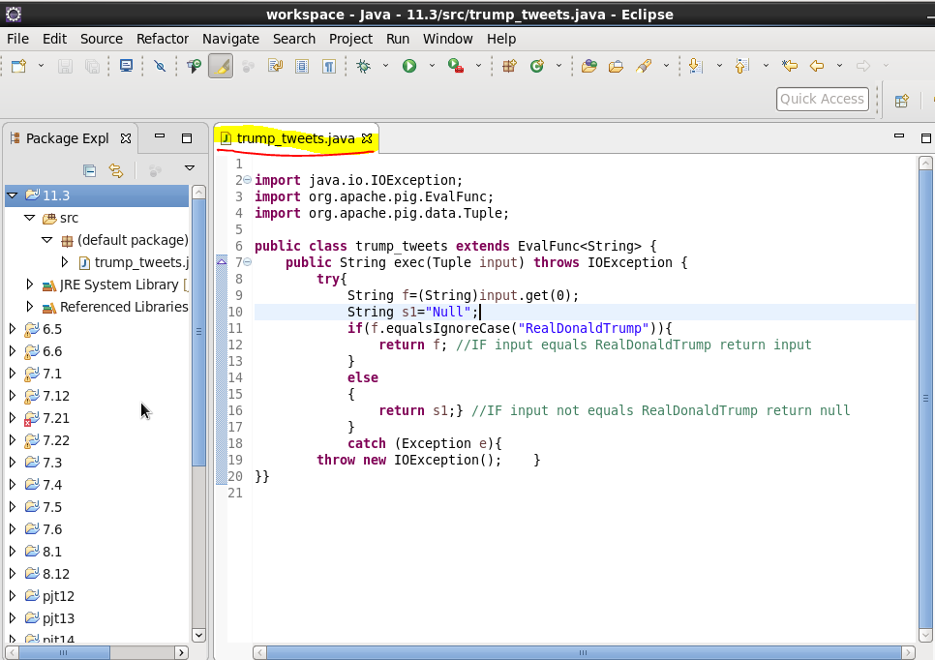

**Pig code :**

**C:\Users\612926\Desktop\2.png**

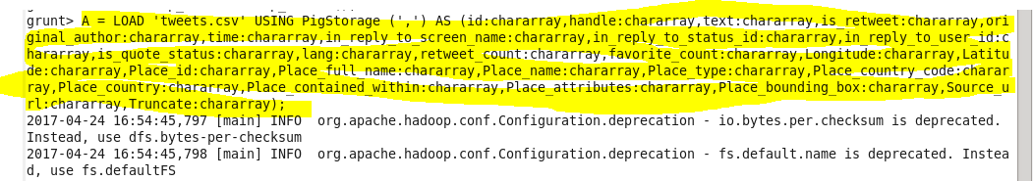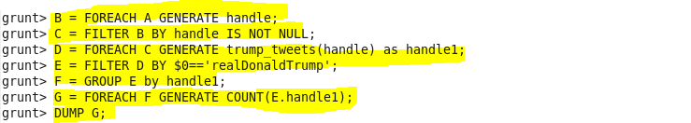

OUTPUT :

